Variables excluded based on correlation matrix. 10 fold cross validation used to calculate accuracy.

1. No variables excluded; no PCA; classes 1&2 and 3&4 lumped

Best classifier: KNN

Accuracy = **77.9%**

AUC = 0.77

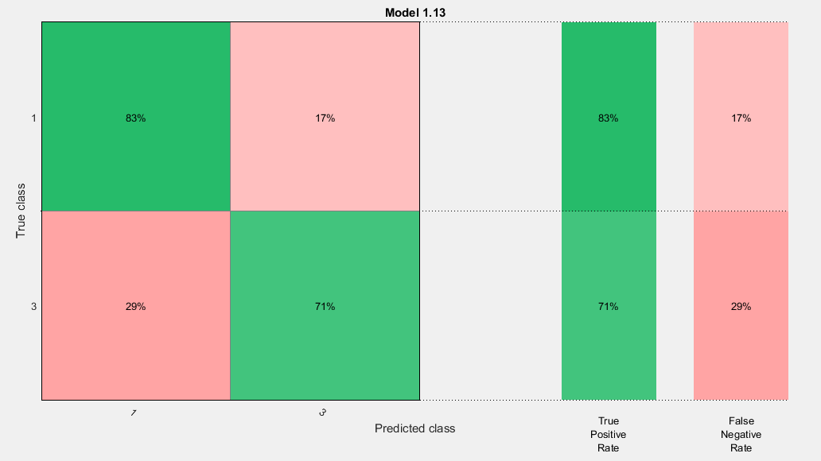

1. Variables 10,13,17,20 excluded; no PCA; classes 1&2 and 3&4 lumped

Best classifier: KNN

Accuracy = **79.2%**

AUC = 0.79

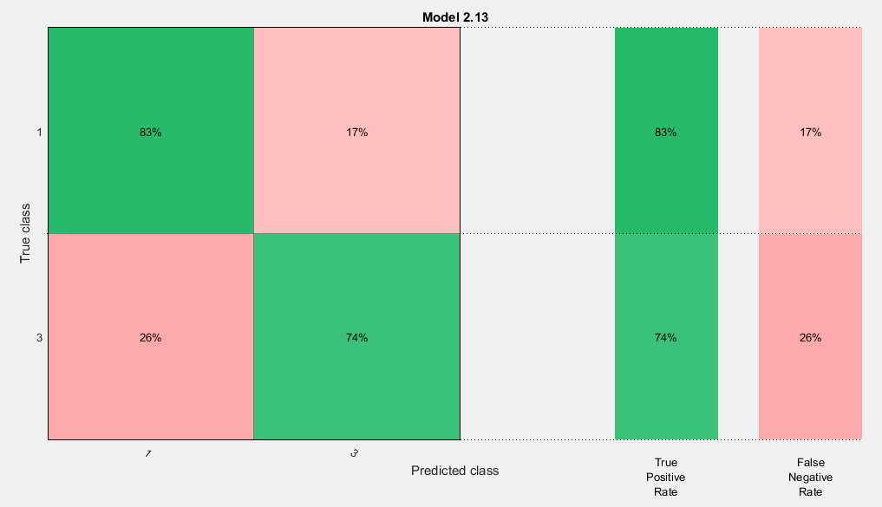

1. Variables 3,4,5,8,9,10,13,17,20 excluded; no PCA; classes 1&2 and 3&4 lumped

Best classifier: KNN

Accuracy = **76.6%**

AUC = 0.77

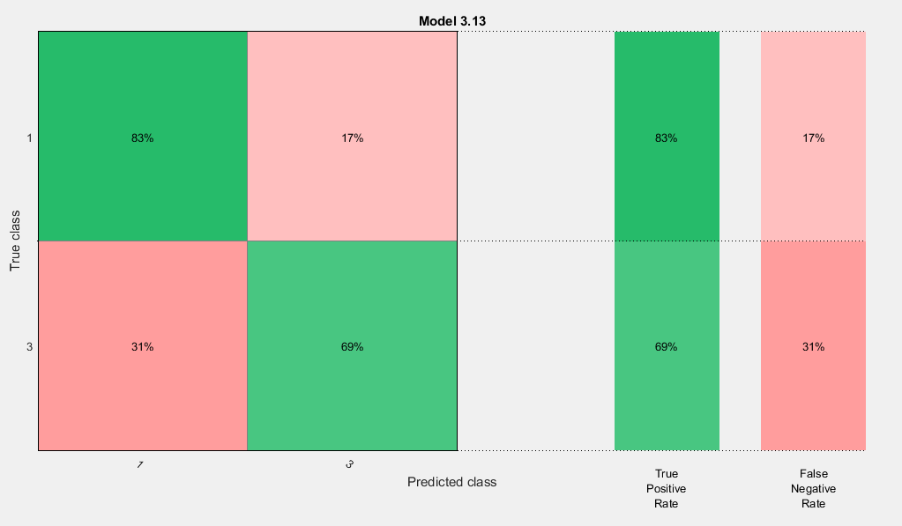

1. Variables 3,4,5,8,9,10,13,15,16,17,20,22,23 excluded; no PCA; classes 1&2 and 3&4 lumped

Best classifier: Cubic SVM

Accuracy = **76.6%**

AUC = 0.77

